1. **Visitor Management System for Guests**

Basic purpose of Visitor Management System is to provide State Of Art solution that shall be reliable, trusted and build with best of technologies available.

This shall be prodigious engineering build from ingenious acumen of VMS requirements of present day housing societies.

Competency of solution:

1. Keep track of entry and exit of Guest entering society.
2. Verification and authentication of visit
3. Smooth and reliable entry-exit of guest.
4. Utilize resources of society like Man Power and Guest Parking with efficiency.

Guests are divided into 3 categories and process of entry and exit from gate will depend upon category of Guest.

**Definition of Guest:**

Visitors visiting residential flat shall be divided into 3 categories:

1. **Expected Guest**: Prior information provided by resident of guest visiting his flat.
2. **Preferred Guest**: Frequent visitors to resident.
3. **Normal Guest**: Visitor without any prior information to security agency.

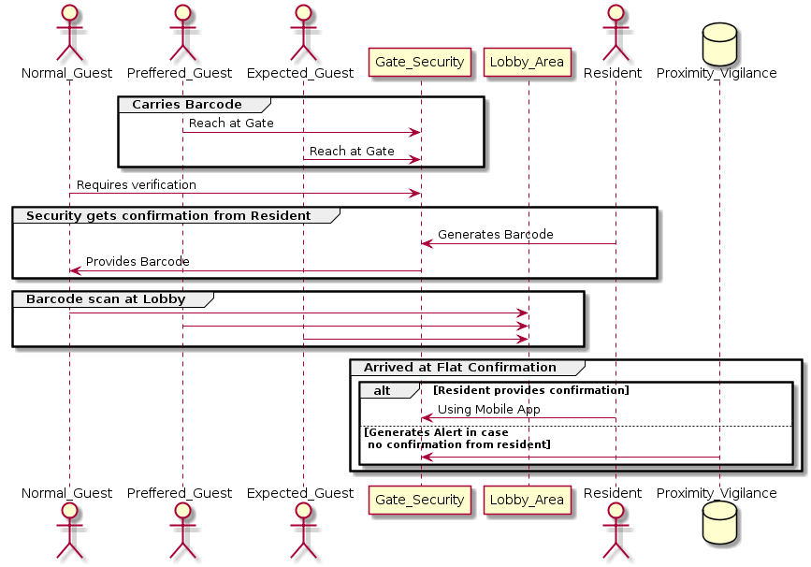

**1.1 Expected Guest:**

**Definition**: Guest with pre-approval for visit.

Passage through society gate shall be smooth. Resident shall share barcode generated from mobile application that will act as pass to society.

Screen Name :

***New Guest-Visit Request***

**Features in Screen:**

1. Resident shall be able to enter details of visiting guest.
2. Generate Barcode
3. Share Barcode with help of sharing application available in device like WhatsApp or messaging
4. Edit Guest Visit
5. Cancel Visit

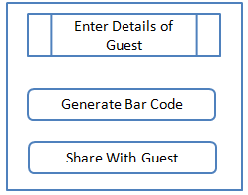

**1.1.1 Below are the entities and actors involved in this process. Not all data will be visible to all actors.**

**Flat** : Information related to Resident are defined by attributes defined in Flat Table.

**Guest-Info** : This contains information related to Guest. Entities required to authenticate and put into process information related to Guest.

**Guest-Visit**: Once Guest request is raised by Resident, his visit will be live. This table defines Parameter to define Live Visit.

**Visit History:** Once Visit is finished, Visit history will be maintained by System which can be used for various data analysis.

**Parking Information**: In case Guest opted for Parking then this table contains data related to same

|  |
| --- |
| **Guest Visit** |
| ID Guest-ID Status(Complete/Ongoing) Visiting Resident-id Image-id of issued BarCode In-Time Out-Time Expected out time Allocated ParkingId Parking Release time Special Request Resident Confirmation Obtained Ongoing Notification-id Visit Grade |

|  |  |  |
| --- | --- | --- |
| **Guest-Info** |  | **Visit History** |
| ID Type Visiting Resident-id(Can be multiple for single Visit) Name Photo-Id Mobile Number Vehicle Number Make of Vehicle Grade |  | ID GuestVisit ID Visit Grade Incident Related to Visit |

|  |
| --- |
| **Flat Info** |
| Flat Number Zone-ID Floor-ID Owner Resident -Type(Owner/Tenants) Primary Resident-ID |

|  |  |  |  |  |  |  |  |  |
| --- | --- | --- | --- | --- | --- | --- | --- | --- |
| **Parking-id** | **Zone-ID** | **Parking Type** | **Parking  Vehicle Type** | **Parking  Status** | **Allotted  Flat-ID** | **Allotted  Guest-ID** | **In- time and date** | **out- time and Date** |
| P1-101 | Z88 | Resident/ Guest | Two-wheeler/ LMV HMV | Ocuppied | O-888 | G-121 | 15:30/02052118 |  |

Resident Mobile ***UserInterface*** for VMS of Expected Guest:

1.1.2 Screen Name :

***Create New Guest Request:***

User Interface shall be designed such that creating NEW Guest Visit request shall not become tedious JOB. (*) marked fields are mandatory to make any new Guest request.

Application shall provide user Interface to enter below details :

|  |
| --- |
| **Guest Visit** |
| ID Name*  Photo-Id Mobile Number*(Must for ***primary*** ***Member***) Vehicle Number Make of Vehicle Time of arrival*  Expected Out-Time* Parking Required (Y/N) * Special Request Number of accompanying Guests(***only for primary guest***) |

1.1.2a Generate Bar Code

After entering above details, Resident shall be able to generate BARCODE. Screen should provide button “Generate”. In case, any (*) entry is not valid User shall receive proper alert. Once Barcode is generated successfully it should be displayed in Screen along with SHARE button.

1.1.2b Share BARCODE

Once User presses SHARE button it shall open, sharing mobile applications in devices like whatsApp and resident shall be able to share Barcode with incoming Guest.

1.1.2c Edit Guest Visit

Resident can edit information related to Guest visit made earlier. In this case new BARCODE will NOT be generated, only request to server will be made and Guest can use same Bar code.

All information can be edited like:

1. Add, delete Guest to/from list.
2. Primary Mobile number and other information related to Primary Guest.
3. Change in IN-Time and out time. In case, IN-time is changed, *previous booked parking slot will become invalid.* Proper warning Alert to Resident shall be provided. New parking slot will be booked if available in new time slot.

1.1.2d Cancel Visit

Resident shall be allowed to cancel visit any time before visit starts with simple re-confirmation popup.

1.1.3 Screen Name :

***Upcoming Visits***

Here Resident shall be able to see all upcoming visits for which he has requested earlier. Resident shall be able to navigate to “edit/cancel visit” screen from this screen.

1.1.4 Screen Name :

***Guest Arrival***

Half hour before scheduled visit, Resident shall be notified by alert/notification in mobile application.

***As guest is on Gate:***

Resident shall again get notification.

In case number of guests are not same as per entered by Resident. Security Guard shall enter details from *Security-Guard mobile application* and Resident app shall get notification, on Clicking Notification Guest detail screen shall open with **Approve** button. Resident is require to press Approve button to let user come inside society.

In case, resident do not press Approve button due to any reasons. Security guard can take confirmation via intercom and thereafter allow guest inside society. Resident application shall receive notification of Approval in his application.

***As guest arrives in Flat:***

Once guest arrives in flat, Resident shall press **Arrived** button and resident mobile app shall keep on receiving notifications till they press Arrived Button. After specific time Server will alert Dashboard in case Resident failed to press Arrived button, Guard shall confirm by intercom and shall raise alarm in case there is any issue.

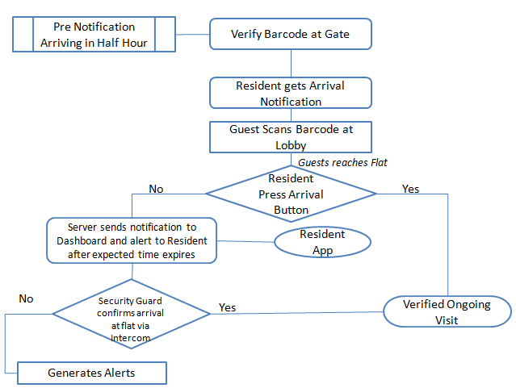

1.1.5 Screen Name :

***On-Going Visits***

Application shall display list of On-Going Visits to Resident. There can be multiple visits going on at a time, so application shall show list of visits and on clicking item in list details of visit shall be available.

Resident shall be able to navigate to Finish/Extend Time (of visit) screens.

Resident shall *not be allowed*to make entry of new Guest to *same visit* once Visit has already started.

1.1.6 Screen Name:

**Extend time of Visit**

Screen shall take input for new timings(date and time) for extended time and after that App shall fetch data from Server to know if parking slot can be extended for specified time or not. While data is being fetched from server “Wait Alert” shall be shown in Resident Mobile Application. If same Slot is available then Simple Alert Pop shall be provided to Resident app for Confirmation.

If not, then user shall receive alert to free the parking space on time mentioned earlier.

Here RULE book of different societies may alter behavior.

1.1.7 Screen Name:

**Finish On-Going Visit:**

Resident cannot mark visit finish but only notified about it once all Guests has left society. Security Guard Application shall be able to mark Visit as finished.

Until then, Resident application will get notification for all events related to visit and duly alert in case of any issue.

*Case 1*: Some Guests(not all) has left the society. Resident shall get notice and Visit still remains ONGOING in Resident Application with details of Guest left and those still remaining inside society.

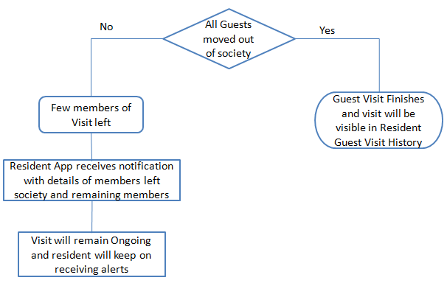

*Case 2*: Guest has moved to another house inside society but left house of 1st resident.

1st Resident shall have option to notify security Guard Application that Guest has left his house.

In this case resident shall be able to navigate to new (Transfer) screen to input

* New Flat number of Visit
* Primary member contact number of Guest

New resident shall receive app notification and on clicking notification application shall open APPROVE screen with details of Guest. Screen shall be similar to NEW Guest screen. Data of Guest Visit shall be automatically copied from ongoing visit and user shall not be bothered to make entries again. He can edit those entries though.

Until New resident presses APPROVE button, Guest visit shall be considered that of 1st resident.

Security Guard application shall have option to call new resident and get his approval. Once approval is provided by New Resident, his mobile app shall show it as ONGOING visit and 1st resident app shall show it as finished visit.

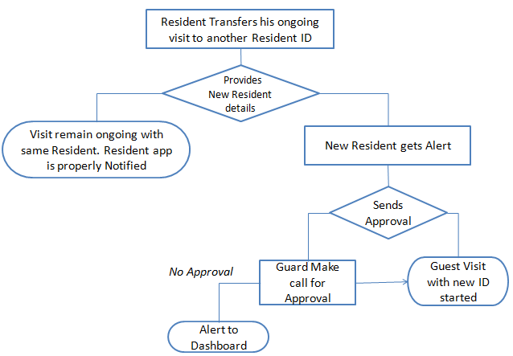

1.1.8 Screen Name:

**History Of Visits:**

Resident Mobile app shall show list of last 10 Guest Visits.

On clicking any list item app shall show details of Visit.

|  |
| --- |
| **Guest Visit** |
| ID Name*  Photo-Id Mobile Number*(Must for ***primary*** ***Member***) Vehicle Number Make of Vehicle Time of arrival*  Expected Out-Time* Parking Required (Y/N) * Special Request Number of accompanying Guests(***only for primary guest***) |

This screen shall have option to create new visit by using details of previous visit.

* 1. **Preferred Guest:**

Only Major difference between Expected Guest and Preferred guest is, Resident shall be entering details of Guest One time and share barcode with Guest which they can use for any Number of visits.

In case Car Parking is available then Preferred Guest will be allotted Parking by Security Guard Application. This may also depend upon RULES laid down for society as Number of Guest Parking HOURS per month may be limited as per society Rules.

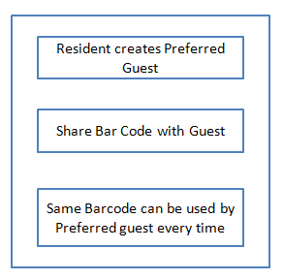

1.2.1 Screen Name:

***Create New Preferred Guest Request:***

User Interface shall be designed such that creating NEW Preferred Guest request shall not become tedious JOB. (*) marked fields are mandatory to make any new Guest request. User shall be able to copy details from History of Visits to create new Preferred Guest.

Application shall provide user Interface to enter below details:

|  |
| --- |
| **Guest-Info** |
| Name Photo-Id Mobile Number Vehicle Number Make of Vehicle |

1.2.2a Generate Bar Code

After entering above details, Resident shall be able to generate BARCODE. Screen should provide button “Generate”. In case, any (*) entry is not valid User shall receive proper alert. Once Barcode is generated successfully it should be displayed in Screen along with SHARE button.

1.2.2b Share BARCODE

Once User presses SHARE button it shall open, sharing mobile applications in devices like whatsApp and resident shall be able to share Barcode with Preferred Guest.

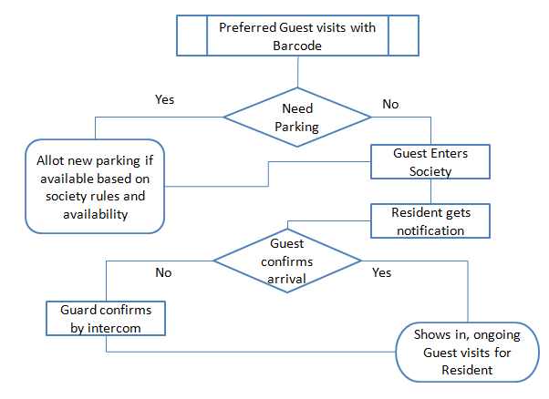

1.2.2c Edit Preferred Guest Details

Resident can edit information related to Preferred Guest made earlier. In this case new BARCODE will NOT be generated, only request to server will be made and Guest can use same Bar code.

All information can be edited like:

1. Update Mobile Number
2. Vehicle Number and Make
3. Photo of Guest can also be changed.

1.2.2d Remove Guest from Preferred Guest list

UI shall provide option for user to remove Guest from Preferred list. Guest will be treated as Normal Guest thereafter.

* 1. **Normal Guest**

Definition: Guest arrived without information .

Guest entry to the society will be with more check and verification at Gate.

Once guests enters society after all formalities, all other features remain same.

